Presentation to the Pittsburgh Public Schools
Board of Directors

October 24, 2002

and Postscript

Wayne Bishop, Ph D
Department of Mathematics
California State University, LA

First of all, let me thank the Board for extending me the invitation to speak to you personally. Dr. Milgram has made a heroic effort to pull evidence out of too much lack thereof. I will be trying to show a less esoteric reality. I will be trying to show you how you=ve been investing too much time and faith in the Emperor=s new clothes and how to move dramatically in a more positive direction.

I=m sure that the letters that you received from me last spring seemed a little off-the-wall, at the very least, unusual. You may recall my motivation, that I had read yet another reference to the success seen in the Pittsburgh schools, this one by Alan Schoenfeld, one of the best known in the industry, stating - with almost certitude - that the current situation is evidence of what is possible, that you are finally rectifying years of injustice. The article was entitled, AMaking Mathematics Work for All Children: Issues of Standards, Testing, and Equity.@ Ample reference, including the initial line, AMathematics Education is a civil rights issue@, was given to civil rights warrior Robert Moses, national creator and head of AThe Algebra Project.@

The words are valid, mathematics education is a civil rights issue. Absolutely. And so is algebra. The problem is getting there. This is not rocket science, it is not new, and it is the same for all races and both sexes in spite of how things are often presented.

This paper, AMaking Mathematics Work@, even Moses=s book, ARadical Equations@, are just so much smoke and mirrors. Unfortunately, much of the smoke and mirrors support in Schoenfeld=s paper is based on evidence from Pittsburgh using the New Standards Mathematics Reference Exam. Another major source of smoke and mirror evidence, in the paper, is from a SF Bay area project that Phil Daro is familiar with, using the MARS (so-called) Balanced Assessments that (I believe) Pittsburgh is intending to introduce this year. In the Schoenfeld paper, high SAT-9 scores and low Balanced Assessment scores are identified as Afalse positives@. Don=t believe it. By and large, strong SAT-9 scores reflect strong, well-prepared students. And low scores, the opposite.

Let me begin with a little history. Some of you, perhaps all of you, are familiar with the NCTM Standards that came out in 1989. The very name AStandards@ was a bait-and-switch answer to the nation=s call for - almost desperate cry for - national standards of educational competence. The lead editorial in my local paper just this past Sunday described the real thing, AThe basic teaching model incorporated into standards-based texts is simple: teach, assess, and reteach to mastery.@ That is not the NCTM bait-and-switch AStandards-based@. Reform curricula claimed to be AStandards-based@ in response to the document, but the movement was already decades underway, the leadership just gave it a new name. Renaissance Mathematics and other programs had been around for quite awhile training elementary school teachers in their Areceived wisdom@ vision of mathematics education. At the secondary level, CPM and IMP were already in prototype form, California always seems to be ahead of the curve on these things, but it wasn=t just California. Core-Plus and others were underway in other places. QUASAR out of the University of Pittsburgh, for example. That one quite literally killed eighth grade algebra at its only California pilot, Spurgeon Intermediate in the Santa Ana District.

In fact, the honeymoon with the new ANCTM Standards@ only lasted a couple of years before observers were noticing that student performance was not improving under these experiments; in fact, it was often demonstrably worse. Data-conscious insiders knew that that would be the case and that standard assessments of mathematical competence would have to be replaced. The response on the part of many within professional education circles was AWho Cares?@ Those old tests were meaningless tests of archaic skills, and even discriminatory. They were prohibiting traditionally underrepresented sub-populations from demonstrating their conceptual understanding in deference to rote mechanical skills better done by the technology of the era; we need Aauthentic assessments@. It was another bait-and-switch. This philosophy was not universal within the industry, however. The first national call for a return to educational sanity that Ahad legs@ was from Zal Usiskin, the head of the UCSMP, the very creators of Everyday Mathematics, the elementary curriculum used here in Pittsburgh; in fact, that is part of the controversy that brings us here this evening.

---------------------------- 2 -----------------------------
"Let us drop this overstated rhetoric about all the old tests being bad. Those tests were used because they were quite effective in fitting a particular mathematical model of performance - a single number that has some value to predict future performance. Until it can be shown that the alternate assessment techniques do a better job of prediction, let us not knock what is there. The mathematics education community has forgotten that it is poor performance on the old tests that rallied the public behind our desire to change. We cannot pick up the banner but then say the tests are no measure of performance. We cannot have it both ways."

Zalman Usiskin What Changes Should Be Made for the Second Edition
of NCTM Standards. UCSMP Newsletter, n12 pp. 10 (Winter 1993)
----------------------------------------------------------------

Or as I prefer to say... ADance with the guy what brung ya..@ The traditional testing really is meaningful and it was weak performance among too many students - on those assessments - that fired the drive for reform. Dismissal of the evidence that the reform was actually making the situation worse - is beyond disingenuous; it is immoral.

Unfortunately, this is not an abstract hypothetical for your district, it is a very real phenomenon locally, and Pittsburgh evidence is being used to preach salvation to you of this Board and to others. [Slide 3] For example, in January of 1999, Dr. Briars informed the PPS Board of Education that ... and in September of 2000 she informed the US House of Representatives, Committee on Education and the Workforce that ... and in March of this year she informed the ASuccess for Everyone@ Conference at the University of Illinois, Chicago Circle, that ...

-------------------------------- 3 ------------------------------
AThe ITBS data illustrates that beyond grade 1, Everyday Mathematics will produce comparable, if not better performance on the ITBS than traditional instruction,@ and that, AGiven the limitations of the ITBS and it inappropriateness as a measure of program quality, the analyses of ITBS data offer little in addition to the NSMRE analyses.@

Dr. Briars, January 6, 1999, PPS Board of Education
---------------------------------------------------------------
AOur work in the Pittsburgh Schools over the last four years demonstrates that dramatic, large-scale increases in mathematics achievement can be obtained.@

Dr. Briars, September 21, 2000, US House of Representatives
---------------------------------------------------------------
Pittsburgh Public Schools has doubled its mathematics performance from 1996 to 2000, Slide 17 of the presentation (Next Slide)

Dr. Briars, March 22, 2002, University of Illinois, Chicago Circle

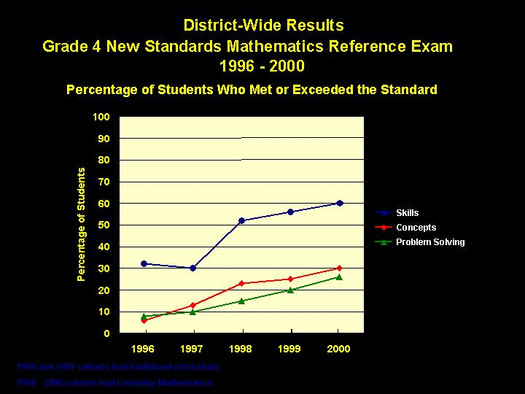

Just take a look at the graphs! Dramatic progress in Pittsburgh!

But instead of confirming such confident claims with evidence, the district ended its use of the ITBS, the granddaddy of traditional standardized tests, focusing instead on the New Standards Mathematics Reference Exam (NSMRE).

Is this claim made before the House committee, Athat dramatic, large-scale increases in mathematics achievement can be obtained@, supported in Pittsburgh evidence? It is it not; the assertion requires complete rejection of Zal Usiskin=s words, AWe cannot pick up the banner but then say the tests are no measure of performance.@

Is the assertion itself true? That is, can dramatic, large-scale increases in mathematics achievement be obtained? Absolutely. I will come back to that critical point later and show the real progress that has been demonstrated; progress that is replicable here in Pittsburgh as well.

What really is the record here in Pittsburgh? Especially, what is the record at the elementary and middle school levels that are so critical to high school and further academic success? And what evidence has the Board been getting? Mostly, a heavy thumb on the scale in favor of the meaningless New Standards Exam and almost no emphasis on the state=s real test data, the PSSA. Until the A No Child Left Behind@ legislation forced a change with this academic year, you were not collecting the kind of evidence that decision makers most need in order to make intelligent, informed decisions. In fact, you still are not. In the testimony before the Board referred to earlier, not only was the ITBS described as an inappropriate measure of program quality that it could Aoffer little in addition to the New Standards analyses@, the state=s PSSA data was never even mentioned. The exact opposite is true about the ITBS; it remains among the best available. But even the PSSA data paints a very different picture of Pittsburgh mathematics education progress.

You saw the PPt presentation of Dr. Briars on September 10 with follow-up addendum on September 18. I have added in the 2001 numbers to the All Student - New Standards slide in order to get apples-to apples data comparison with the National bar presented therein:

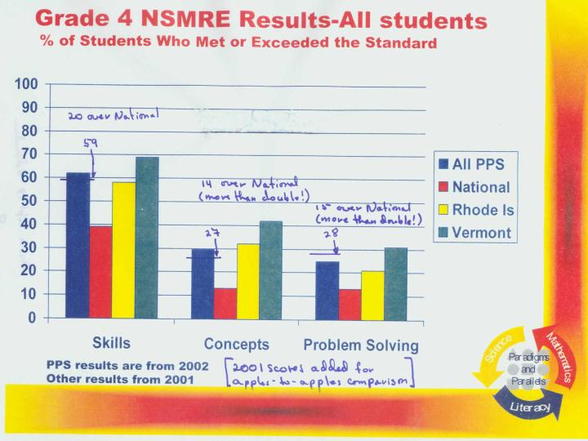

What really brought me to Pittsburgh, however, was a conviction that the claims of success for low-SES, especially African American, students with the Everyday Mathematics and Connected Mathematics curricula were overblown. Here is the comparable slide focusing on them:

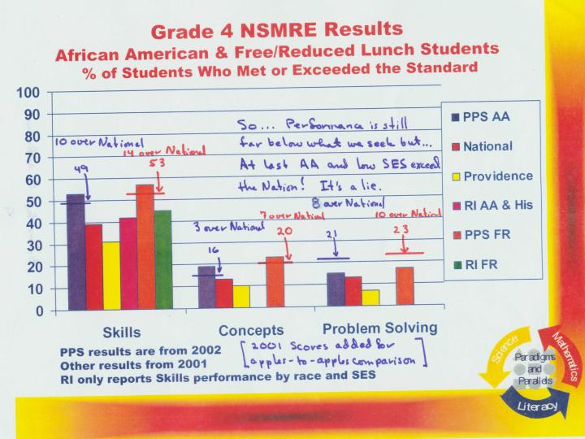

Once again, notice how these students exceed the National population. Can we really believe this information? What really is the record here in Pittsburgh, especially at the elementary and middle school levels that are so critical to high school and further academic success? Focusing on the 5th grade in 2002, so the same African American cohort that you just saw we have:
-------------------------------- 7 ------------------------------
PPS Grade 5 Total Advanced Proficient Basic Below Basic
2001-2002 Math 1170 6% 15% 26% 53%

And it=s even worse than that; 29% of the 5th grade African American students were not even tested. Add in almost 700 students to the already nearly 900 who tested at the Below Basic level out of the district=s almost 2400 African American 5th grade students and you have fully two-thirds* already operating Below Basic by the end of 5th grade.

* Note: This was an error. I did some inadvertent double counting; the correct figure appears to be 269 not tested out of the 1959 total and 897 Below Basic or 60% Below Basic or not tested.
----------------------------------------------------------------

So we claim ASuccess for All@ and that ANo Child will be Left Behind@ when two-thirds* of the African American children in Pittsburgh have already been left behind by the end of Grade 5. Are they well ahead of their national counterparts as the New Standards record shows us? Nonsense! The New Standards= identification of ASkills@ competence is just more bait-and-switch. They=re far behind the rest of Pittsburgh, that is already below the 15th percentile among Pennsylvania districts, a state that is, in itself, not strong among the states. It is past time to start telling it as it really is.

At least some of the PSSA data for 2002 was included in the presentation to the Board on September 10 but care was taken to misinform. Pittsburgh=s AMainstream and Gifted@ students were graphed against the state=s AAll@data. That was rectified in an addendum to the Board on September 18, in response to board member questioning, but sometimes numerical data is preferable, especially noting the performance categories. With the decline of 2001-02, Pittsburgh=s 5th grade has dropped back almost to the level it was when the state began reporting this data in the 1995-96 year.

-------------------------------- 8 --------------------------------
Grade 5 PSSA
Year Math Reading
A P B BB A P B BB
1995-96 1200 11 18 27 44 1190 13 17 27 43
1996-97 1220 11 18 28 43 1220 12 19 30 39
1997-98 1220 11 17 30 43 1210 13 19 28 41
1998-99 1250 15 19 33 33 1230 14 19 31 36
1999-00 1240 14 18 29 37 1240 15 18 28 37
2000-01 1240 14 23 27 36 1240 13 28 23 37
2001-02 1230 13 20 25 42 1230 5 39 23 34 Not tested: 24%*
-----------------------------------------------

Dr. Briars informed us the distributions are no longer comparable with earlier years since the state=s reference is no longer quartile distributions but now is performance levels. That is misleading information on a couple of counts. For one, the state=s distributions remain quite close to quartile distribution (i.e., four equal parts of the total database) but beyond that, the state itself has moved up a little, the 2001 state distribution had only 22% in the Below Basic performance category, so that makes the 42% Abelow basic@ even worse on quartile basis, probably it is back to 44%. With the growth in the percentage* who don=t even take the test, actual performance is probably below the 1995-96 level! [* Again, this was a misread of district data. Most of these students were tested.]

Even without factoring in those untested students, there has been a small but steady decline since a high in 1998-99. Will the decline continue? I certainly do not know. My guess is yes but I really have no way of knowing. And neither do you. But you should. How should you know? By knowing how the first graders are doing, the second graders, the third graders, and this= years 4th graders, and not with the silly New Standards exam that has been telling you almost nothing but inflated rhetoric. You cannot get better information than what you used to get from year-by-year grade-level administration of the ITBS but that excellent information was abandoned years ago.

Will you be getting that kind of data? No, but you should be. Dr. Shula Nedley recommended a sound assessment system for the district in a memorandum of August 2, 2002, in which she recommended that the SAT-9 exam be administered annually in Grade 1 through Grade 11 in both reading and in mathematics.

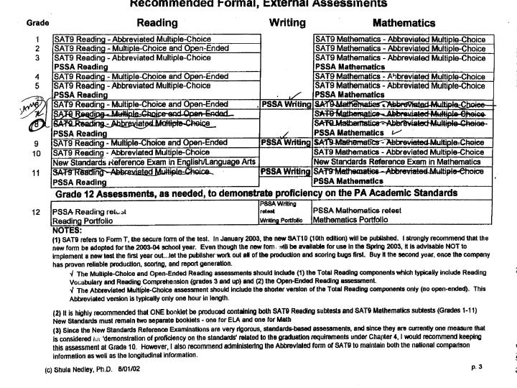
Her logic for this recommendation was unassailable:

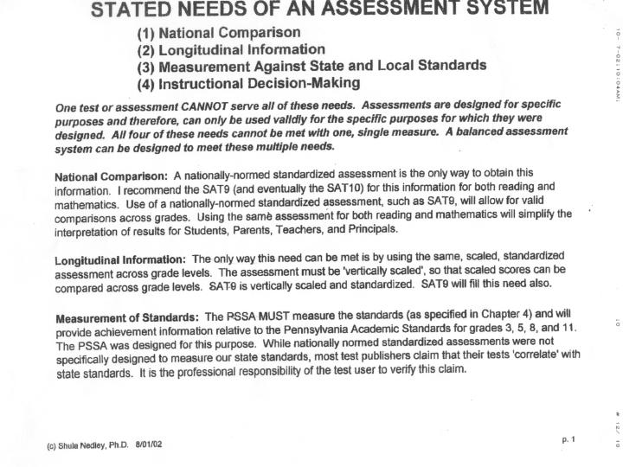
The one primary point of this slide is: AA nationally-normed standardized assessment is the only way to obtain this information. I recommend the use of the SAT9 (and eventually the SAT10) for this information both in reading and mathematics. Use of a nationally-normed standardized assessment, such as the SAT9, will allow for valid comparisons across grades.@ And again, A The only way this can be met is by using the same, scaled, standardized assessment across grade levels.@

Was this the district=s decision? Not at all; the district chose to ignore this sensible assessment program recommendation and get around the ANo Child Left Behind@ mandate just by adding in, at other years, the (what I assume that is the CTB/McGraw-Hill MARS) Balanced Assessments! Let=s see the next slide for comparison with the last one:
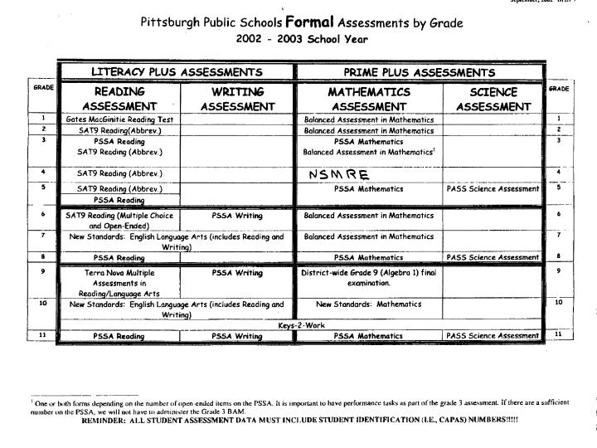
When did the Board approve such a counterproductive policy? Such a mishmash of unsupportable and unrelated activities? My understanding is that the Board never even saw the August 2 proposal. Apparently, this critical decision was made administratively.

By contrast, the state of California chose to adopt the same SAT-9 for both reading and mathematics beginning with the 1997-98 school year and to make the results easily accessible via the Internet. That was also the year that the state mathematics content standards were approved so the 1998 numbers make an excellent baseline. Granted, we have lots of districts that are still dragging their heels but the districts that Agot with the program@ early and adopted compatible curricula as soon as they were approved for the Fall 1999 year (so now three years of test data) have made startling progress. Azusa, Baldwin Park, and Sacramento City are among my favorites but Baldwin Park above the others because it was the home of the Serrano Decision that equalized school funding across Los Angeles County some thirty years ago. In these thirty years, little progress was made but in the last four, it has been startling:

---------------------------- 12 --------------------------------
Baldwin Park USD SAT-9 Math Ave NPR
Grade 1998 1999 2000 2001 2002
2 19 30 43 48 57
3 22 29 49 53 59
4 23 24 36 45 50
5 25 29 34 46 51
6 38 42 48 52 59
--------------------------------------------------------------

This district is heavily Hispanic with severe English language deficit problems but a comparable district with a high African American component is the Inglewood district that Dr. Milgram mentioned. It is gradually changing to Hispanic but remains heavily African American as well. The most famous of its schools are Bennett-Kew and Kelso (both at about 50-50), but right in there are several others; in fact, now more than half the district=s schools are performing very well in spite of demographic numbers that usually correlate with poor performance. California=s data base is still getting the bugs worked out but when the Academic Performance Index first became available, I queried the entire state=s API list of some 4800 elementary schools for top four decile performance intersected with at least 70% low-SES. Amazingly, there were only 25 schools in that list from the entire state. I noticed that a couple had tested fewer than 80% of their students so I threw in a 95% test-take factor that brought it down to 19 schools. I then threw in a 20% LEP factor and that brought it down to 13 schools out of the 4800. Five of them were in Inglewood with only 13 elementary schools in the district. Payne, Hudnall, and Highland were the other three. That is statistically breathtaking.

What about Pittsburgh? It is breathtaking, too, but only in it=s audacity. It has been representing itself to the nation as some kind of mathematics education salvation that is absolutely unwarranted in data.

UCLA=s CRESST Center published a widely quoted paper, coauthored jointly by Dr. Briars and Dr. Lauren Resnick of the University of Pittsburgh, that borders on the unconscionable. The PRIME Plus office has adamantly refused to name the schools that were identified therein but it=s AA@ classification, the high African American and low SES factor schools, made that identification easy to confirm from the specifications given in the paper. Result? Both the school designated as the Astrong@ implementer of Everyday Mathematics, with supposed great success, and the Aweak@ one, have been almost interchangeable with regard to the state=s data, the PSSA at Grade 5. I cannot overstress the importance of Dr. Nedley=s proposal, being able to follow grade-level cohorts from grades 1, 2, 3, and 4 prior to the state=s 5th grade assessment the PSSA, but the district has made sure - and it is continuing to make sure - that you do not get that kind of data. Specifically, we have the following five year interval data for these schools.

Belmar was the AWeak@ implementer, Madison, the "Strong", and both have degenerated from their distributions five years ago to be outrageous in 2001 and again in 2002. For contrast, I=ve added a couple of schools that have tried to resist being forced to Astrongly@ use the Everyday Mathematics philosophy, Lincoln El. and Vann El. Dr. Briars did include a list of current AStrong@ Everyday Mathematics implementers. Needless to say, these were not among them. I was only looking at schools that were low-SES, and high African American enrollment, close to 100% in fact, and Lincoln and Vann are the schools that need replication, not the others.

--------------------------------13 ---------------------------
Belmar El. Total High High-Middle Low-Middle Low
1996-1997 Math 1300 14% 46% 30% 9%
2001-2002 Math 1106 0% 8% 24% 68%

Madison El. Total High High-Middle Low-Middle Low
1996-1997 Math 1220 8% 12% 53% 28%
2001-2002 Math 1133 5% 7% 23% 66%

Lincoln El. Total High High-Middle Low-Middle Low
1996-1997 Math 1210 0% 11% 61% 29%
2001-2002 Math 1281 20% 24% 34% 22%

Vann El. Total High High-Middle Low-Middle Low
1996-1997 Math 1140 0% 8% 32% 61%
2001-2002 Math 1282 10% 39% 25% 25%
----------------------------------------------------------------

It is reasonable to conclude from its outrageous performance drop that (the AWeak@?!) Belmar had been performing normally - even above socioeconomic school predictions, at least with respect to mathematics - until the Everyday Mathematics program finally took over. Other explanations are possible, of course, but to not even mention the PSSA results in the CRESST Report=s analysis, borders on the unconscionable. Factor in the untested students at Belmar and Madison and you have more than three-quarters of their students at Below Basic.

It is useful to note that both Lincoln and Vann have a single mathematics teacher in grades 4 and 5. That can help with any curriculum but it is especially important if trying to use a less traditional one such as Everyday Mathematics. There are untested students at these schools, as well, so they are not quite as rosy as this appears, but they still indicate substantial progress.

What can we tell from these numbers for both Belmar and Madison? Well they=re bad, of course. And they=ve gotten worse over the last five years. And it=s not just these schools, although they are representative. The bottom line is that they=re not ready for a decent pre-algebra program in middle school and they won=t be ready for real algebra in high school, much less in the eighth grade which is the national standard for strong schools these days. Hundreds will drop out and, many of those who do not drop out will join the ranks of the African American students who are not PSSA tested*, a full 40% by Grade 11.

Painful as it is to dismiss the academic futures of 5th grade kids, reality is that this has already been done. By the district. On average, these kids are not ready for a good pre-algebra program. That includes a lot of ordinary fraction work, a lot of beginning symbolic manipulation, signed number arithmetic, and above all, lots of straightforward word problems of a mixed nature, simple ratio problems, simple distance problems, and the like. These are dismissed by some as being Acookbook@ but that is not a problem as long as the emphasis is on the mixed nature of the word problems. They do not have to be hard nor creative, but they must be plentiful and with enough variety that they must read to be understood. This not only enhances mathematics, it enhances careful reading.

Since these fifth grade students could not handle real pre-algebra, what did the district do? It brought in Connected Mathematics, a program that has almost no ordinary fraction work, very little symbolic preparation, and far too few of the word problems that I was describing. And these are done as Ayour group decides@ instead of with each individual student reading and learning to understand exactly what is intended therein. Of course, the district also has a reading problem that makes the reading and understanding of word problems all the more difficult. So work on both. Don=t claim that Connected Math is some kind of district (or national!) salvation; just get to work... in kindergarten, in first, in second, etc. By 6th grade, an overwhelming majority of students are already lost. Their academic careers predetermined to failure.

The next question is whether or not to extend this algebra-lite approach on through high school? Clearly the majority of those fifth grade black kids who were already performing at a Below Basic level will have made less than adequate progress through their middle school experience. Perhaps use IMP or Core-Plus or some of the other reform curricula that has been highly praised in some circles? Highly praised in some circles does not include the SAT takers that Dr. Milgram talked about. I personally consider this to be another moral issue. Again, Bob Moses of AThe Algebra Project@ asserts correctly that AMathematics is a civil rights issue@, moreover that algebra is a civil rights issue. As Dr. Milgram has reminded the Board, with the AIn the Toolbox@ reference, the content of Algebra 2 is a key and students do not get there without competence in Algebra 1. Without competent algebra preparation, followed by competent algebra curriculum and assessment, do not expect to stem the bleeding from public schools of those students who are the children of informed, modestly affluent parents. They will continue to flee further out to nearby towns that are more effective, move to private schools, or even be home schooled, a phenomenon that used to be the refuge of only conservative kooks but now is widely represented across the political spectrum.

Coming back to the California situation before ending, once again, here is that Baldwin Park slide:
---------------------------- 14 --------------------------------
Baldwin Park USD SAT-9 Math Ave NPR
Grade 1998 1999 2000 2001 2002
2 19 30 43 48 57
3 22 29 49 53 59
4 23 24 36 45 50
5 25 29 34 46 51
6 38 42 48 52 59
--------------------------------------------------------------

What is Baldwin Park doing that is paying such striking dividends? The district is actually doing what Pittsburgh claimed to be doing in an October 3 Press Release that confirmed its silly assessment scheme, AIn the spirit of leaving no child behind, we have in place a variety of research based, best practices in helping students overcome their learning deficits, Pittsburgh may become the first district to comply with the >No Child Left Behind= legislation.@

Instead of such empty puffery, California is showing the country how to do it. Solid, sensible curriculum with year-by-year, school-by-school, grade-by-grade, nationally-normed results that anybody with Internet access can check in seconds. Class-by-class data is available to authorized school personnel, most critically to site principals. That informs principals of meritorious performance - i.e., who to brag about and who to emulate - or of problems and allows intervention if a teacher is not carrying her class adequately. Districts such as Baldwin Park are making it clear to everyone that documented content competence is the key to student success, not the latest fad curriculum, the next generation of graphing calculators, or ANew Standards@ exams or ABalanced Assessments@; but the real thing. Curricula that work have been adopted, and progress is working its way up developing the fundamentals as it must. There is no other way. Sometimes the press, and the abundant nay-sayers (although far fewer than a couple years ago) point to the fact that progress is not nearly so dramatic at the upper grades. There is a missing word; it=s that the progress is not nearly so dramatic at the upper grades yet. It is coming and none too soon, Separate-but-Equal was declared unconstitutional almost half a century ago, but finally it is ending. Real performance, real algebra, real equity.

When the SAT-9 data for 2002 came out in late August, I updated a summary of performance in several California school districts that have been able to accomplish extraordinary success with students who, in years gone by, would have been dismissed. California still has not implemented a mechanism for querying the state=s database for primary curricula used, if any, so the document is hit and miss instead of being systematic, but it is useful information and I=ve brought along copies for the Board.

We were asked to evaluate and to offer our opinions about the district=s use of Everyday Mathematics at the Elementary level, Connected Mathematics in Middle Schools, and to offer advice in regard to the administration=s proposal to change its secondary mathematics program for all students. This change would replace the current series, Algebra I, Geometry and Algebra II, with an integrated mathematics program.

I am a firm believer in emulating and improving upon demonstrated success so - and I am speaking only for myself here - I would say that the high school concern is entirely misplaced. It represents a mistaken perception of the problems that beset the district and of the importance - and of the opportunities - associated with the content of a traditional secondary curriculum (not that you really have one) built on the only foundation that works, solid pre-algebra preparation on down to the beginnings of elementary school mathematics.

The writers of the California Standards, that are guiding the progress that you see reflected in these numbers, began with a target. That target is exactly what strong middle schools achieve all across the country, real algebra in Grade 8. What they did not recommend, however, is to do what Pittsburgh has done, just pretend that everyone is doing algebra by chronology instead of by preparation, and assign everyone to a class called Aalgebra@. What they did was work backwards, down through the grades, identifying what must be being done, in what order, that ordinary students could be successful in algebra by Grade 8. These are not the nebulous, almost nonsensical, Ahigher order thinking skills@ substitute for identifiable, testable standards but the real thing; in fact, they=re the best in the country. The next step was to identify curricula compatible with these standards on a grade-by-grade basis.

Surprisingly to some, ahead of everything else, came the tests, tests compatible with the goals of the ANo Child Left Behind@ legislation, years before it was enacted. The mandate was for an off-the-shelf, nationally-normed, exam in reading and mathematics with no calculator assistance, just pencil and paper. The state settled on the SAT-9 but the ITBS, CTBS, ERB, CAT-5 or other would have been as effective. This has enabled us to easily document the progress that some schools have made on a year-by-year, cohort basis. This information, trivially accessible via the Internet, has been critical.

Since a contract with Harcourt for SAT-9 Reading is probably already signed, I recommend that the Board approve Dr. Nedley=s August 2 assessment memo - this year, and cancel any contracts with the New Standards and the Balanced Assessment people - and develop an accountability plan for principals based on performance tied thereto. Beyond that, I recommend that the district adopt the California Mathematics Content Standards in total; they=re online so free. Beyond that, I recommend that Pittsburgh replace its K-8 mathematics curricula as soon as is practicable with curricula consistent with that recommendation. PSSA scores would rise significantly and across the socioeconomic spectrum.

The current Board was elected in part to help bring knowledgeable people back to the Pittsburgh Public Schools. This would be a dramatic and effective first step toward successfully meeting that goal. But it will take time. A lot of time. Knowledgeable people have been trained to be wary and our mammalian instinct to protect and to prepare our young is a very powerful force.

Thank you.

--------------------------------------------------------------------------------------

Postscript:

The school visitations were interesting and informative; we met some very talented and dedicated principals and teachers who were providing quality mathematical education. The PRIME-Plus staff is a talented resource and the office operates with a budget that most districts can only envy.

On the downside, however, the district’s curricula and assessment programs appear to be being held in place primarily by strong leadership committed to their survival in spite of substantial evidence of their ineffectiveness. The numbers simply do not match the rhetoric. Principals of demonstrably more effective elementary schools are making sure that mathematics is being effectively taught even to the extent of purchasing and using more traditional mathematics curricula for their daily programs. One gets the impression that there are others who are less willing to risk offending the central administration yet chafe that their curricula are less than as helpful as they could be and should be.

Schools that have made remarkable progress on the 5th grade PSSA, and that we explicitly requested to visit, were excluded from the Thursday schedule. Moreover, there was no Friday schedule with these original requests honored so an opportunity to meet with the most effective schools among those that have a high percentage of minority students really appears to not to have been on the agenda at all. Some special requests were honored on Friday and those opportunities were informative but too late to be included in our Thursday evening reports.

Contact with secondary schools was also disappointing. Meetings with secondary schools that should have offered us the opportunity to openly discuss controversies among faculty and between faculty and district were not arranged, even with an overt request for a specific school with which I had had prior contact and at which “standards-based” controversy does exist. A private email from one of the teachers at one of the schools reinforces a suspicion that the lack of contact was by design, “There was no way you were coming to Xxxxx. We were not even told about the afterschool meeting until the following day.”

The one high school that I did visit, Langley, is a major pilot site of the Carnegie Cognitive Tutor program. I saw the installation and had a fruitful conversation with several faculty over lunch after having observed both the computer component and the classroom component. It was the second year curriculum so, although of a so-called “integrated” nature, the focus of the year is on geometry. I was more than a little surprised to find that there is not a vestige of proof in the entire course. Since proof is almost synonymous with geometry in traditional programs, to have it eliminated entirely - in a program supposedly developed by the world famous Carnegie-Mellon cognitive researchers - was a bit of a shock. A look the district syllabus for the geometry course, especially the Regular and PSP but the CAS classes as well, shows that this is all by design. The regular textbook is Key Curriculum’s Discovering Geometry, considered by some to be among the worst available, and the syllabus is heavily into “discover formulas and solve problems”, not know statements of geometry and not prove standard theorems of geometry.

As a concrete example, the Pythagorean theorem is famous from antiquity as a theorem, not as a likely conjecture, yet the syllabus has “Discover and apply the Pythagorean Theorem”. This is exactly what the thick Carnegie text has students do, a few calculator exercises that lead to a conjecture of the theorem, its statement, and that is where it ends. By contrast, this level of depth is only the Grade 7 California mathematics standard, and the corresponding standard for California’s real geometry course is “Students prove the Pythagorean theorem” and lots of less sophisticated statements as well. To still be “discovering” the theorem, and never carrying the mathematical result any deeper, is inappropriately shallow for regular students. All training in deductive logic that is so critical to the sciences, mathematics, and engineering as a career base is being denied to regular Pittsburgh students. Even more important, the development of logical deductive human thought processes is being denied. Apparently, formal deductive logic is only taught to the CAS students, only late in the course, and only if time allows. The implication to teachers is clear, don’t spend much time on it; it won’t be on the district final.

The district has a policy that everyone be in algebra or beyond by high school and the situation can only be objectively assessed as a disaster. Instead of getting prepared for algebra and then actually “doing” algebra, the decision has been to put everyone into algebra, ready or not. I was not allowed to see any school’s grade distribution but the actual high school performance can safely be assessed because there is a districtwide final examination and we were given one year’s results. We were only given student performance data from year 2000 so it is not clear that the 2001 or 2002 results have ever been analyzed but the 2000 year is enough to see the truth. The most reasonable portion of the algebra final is Section III, a straightforward test of 25 multiple choice items with four or five choices on each. Sections I and II have some misnamed “standards-based” features that are the antithesis of real algebra standards and should be dropped from the district exam. For example, “Write a short memo to Paulie explaining which plan would be best.” Such items actually detract from focusing on algebra.

Section III of the examination, however, should be being used as the primary assessment of the district’s various experiments with algebra innovation, be it IMP, CPM, Core-Plus, Carnegie, Prentice-Hall Algebra or any other program or textbook to come along. Instead of a public report to the Board of comparative student performance of each on these experiments using this objective exam, the data from the 2001 and 2002 exams appear to never have even been compiled much less used effectively.

The district claims to be “standards-based” so how is it doing in algebra, this critical gateway to academic success? Hideously. A quarter of the high school students barely beat the Section III score that they’d get by random choice since they are not penalized for guessing. Only 10% met the standard of at least 70% correct. Half the students scored only 40% or below correct, even with the 20-25% just for guessing. Some 20% of registered high school students didn’t even show up to take the final. Include them and the district is down to only 8% meeting its reasonable algebra standard. The word “standard” becomes almost meaningless if most people who do pass the course don’t meet the standard. Most of these will be going nowhere, academically speaking. They’re at a gateway with the gate slammed shut.

Although not nearly good enough (95% success on the Section III test is possible with this group!), the middle school algebra performance is much better; almost half did meet the standard and only about 15% scored at the 40% or below level; less than 2% of those enrolled failed to take the district’s final exam. The middle school kids who have been placed in courses called algebra do seem to be better prepared for algebra although the mathematics itself tends to be modified to be barely recognizable as competent algebra. The “discovery” focus of the district is to such an exaggerated extent that one middle school student’s experience was illustrative. As he described the situation, “guess and check” is pushed as a legitimate algebraic solution strategy (it is not!) and three guesses are to be recorded “first” no matter how silly or artificial. Result? Those such as he are, in spite of the district’s misguided focus, learning the power and skills of genuine algebraic solution to such problems. First they do the problem correctly. That is, they sketch a picture if appropriate, describe the situation algebraically, solve the algebraic problem correctly and efficiently, and finally interpret the algebraic solution back in terms of the original situation. There’s still the question of the two superfluous guesses, of course, so they entertain each other with such things as guessing area to be negative.

One other lingering disillusionment, we never were provided the list of PPS schools singled out for study in CRESST Report #528 in spite of the request in our original proposal and repeated requests before and after and in spite of signing confidentiality statements to minimize embarrassment to the schools in question. It is only reasonable to assume that there are professional interests at stake making sure that the Everyday Mathematics track record at these schools does not become known to the Board or to outside observers. It is only reasonable to assume that it would contradict the inflated rhetoric of the CRESST paper, the US House testimony mentioned herein, etc. The closest we came to getting the names of these schools was a memorandum, that we were instructed to keep confidential, from Dr. Briars on our arrival. It was dated October 23 and my analysis of April 10, 2002, to the Board was thoroughly discredited therein.

Without having the actual names of the schools to confirm school demographics against those published in the CRESST report, I stand by my earlier conclusion that Belmar was the “Weak Implementer” of the Everyday Mathematics curriculum and Madison the “Strong”. Furthermore, I continue to believe that Belmar’s utterly shocking performance drop from the 1995-96 year until now was not as described in her memo to us, “Belmar was a strong implementation school in the CRESST Report: all the grade 3 teachers in 1996-97 and the grade 4 (a mathematics specialist who taught all the grade 4 and 5 mathematics) were strong implementers,” and further that, “as the Cohort History illustrates, students in the 1996, 1997, and 1998 had strong Everyday Mathematics instruction in grades 4 and 5.” Beyond the strong demographics alignment, part of my reason for still believing that Belmar was the school was from our Thursday morning meeting with teachers from various schools, including one from Belmar. She reported that Everyday Mathematics had little presence at Belmar in those years, a Weak Implementer at best. Moreover, the strong fifth grade performance appears to have been more due to the school’s former textbook series, Silver Burdett, that was still very much in use at those grades at that time. What she further said was that the overall school decline at Belmar was in part due to yet another program that I would characterize as typical education “salvation ministry”, a program called “Vision 21".

This program had many objectionable features but dumping a working mathematics program seems to not have been among them; it seems to have been more focused on language considerations. Because of that focus, Belmar seemed to have been able to fend off “progress” in mathematics for a few more years, I suspect due to that mathematics specialist and their old reliable mathematics textbook series.

Asking around the district thereafter evoked universal derision of Vision 21. I had never heard of it but I did ask the web for links. One reference of interest was from Newark, NJ, “They [students] demonstrate results that are not unlike those found in Bank Street's collaboration with the Pittsburgh public schools (Vision 21, from 1994 through 1996). Students in both exhibit higher degrees of language and literacy skills. They are more self-confident. Their parents report being impressed with the children's knowledge and questions. They know their children are learning, and, increasingly, have become more involved in the children's education.” Apparently the Pittsburgh district has a history of making a name for itself and/or its leaders by jumping onto some current fad while making sure that the public and its Board of Directors do not have access to valid and reliable student performance data such as the PSSA or district final exam results to make reasoned decisions about its efficacy and toxicity.

These critical data are not compiled and reported to the Board on a pilot-by-pilot basis but this should be being done annually to monitor progress, including both successes and failures when indicated. Glowing reports and New Standards Exam “data” are held up to the world but steady cohort tracking of schools with an instrument that meets outside scrutiny - and public for all to see - appears to be effectively and perhaps deliberately avoided. The Grade 8 and Grade 11 PSSA numbers have gone up a little and that probably is real but they remain far below state averages. Of the three, however, the Grade 5 PSSA is the most grade-level content appropriate and performance has been slowly but steadily declining since 1999. Meanwhile, the district website self-applauds “Assessment Results show Improved Student Performance”. There is no mention of the fact is that the district is far below state averages at every grade level and declining at its most basic indicator level, Grade 5.

Instead of replacing “Vision 21" rhetoric with its current “standards-based” rhetoric, the district needs to pursue a focus toward genuine success in algebra. Not changing the algebra assessment device (except for the phony “standards-based” features!), not ignoring it entirely, just getting with a program of proven success. And it cannot get there without a major refocus of the programs that support algebra competence. That will require dropping Connected Mathematics ASAP and replacing it with a solid prealgebra program while developing a meaningful districtwide prealgebra examination that is objectively scored so that it is possible to determine who is and who is not ready for algebra instead of requiring students to do the impossible - and then pretending that they are - and which programs are most effective at improving the situation.

What are the prealgebra skills that need to be developed in order to be successful in algebra?

- Competence with simple ordinary fractions, things like (2/3) - (3/5) and (2/3)(3/5).
- Simple ratio problems, especially in verbal form, such as, “If the class ratio of boys to girls was 2 to 3 and there were 30 in the class, how many girls were in the class?”
- Simple signed number arithmetic.
- Simple linear equations such as, “If 2x - 5 = 11, find 3x - 5.”
- Algebraic representation of simple verbal situations such as, “If n is some unknown number, represent 4 less than twice the number.”

Students with these competencies will thrive in real algebra and replacing real algebra with IMP, CPM, or Core-Plus will no longer be under discussion. Not the most glitz, not the most federal support, just the most effective. Fix algebra readiness and algebra competence and the PSSA assessments will take care of themselves.

Wayne Bishop, Ph D
Department of Mathematics
California State University LA

(323)343-2159
wbishop@calstatela.edu

